**National University of Computer and Emerging Sciences, Karachi  
FAST School of Computing**

**AL2002 / AI2002 -Artificial Intelligence, Spring 2024**

**Project Title:**

**AI Gym Trainer, Fit Sync App with Diet Recommendation System**

**Course Instructor**

Sir Nouman Durrani

**Group Members**

Kantesh Kumar (21K-3426)

Talha Shahid (21K-3355)

Ahsan Ashraf (21K-3186)

Moiz Alam (21K-3966)

**Introduction:**

In today's fast-paced world, maintaining a healthy lifestyle has become increasingly important. However, many individuals struggle to find the time or motivation to engage in regular exercise and maintain their diet as well as choose what to eat. To address this issue, we have developed an innovative solution: the AI Gym Trainer, coupled with the Fit Sync Android app having diet recommendation system. This comprehensive system aims to revolutionize the way people approach fitness by providing personalized workout guidance and seamless integration with their mobile devices.

**AI Gym Trainer:**

The AI Gym Trainer serves as the backbone of our project. It utilizes computer vision techniques to analyze users' movements during various exercises, providing real-time feedback and tracking their progress. The trainer offers a range of exercises, including single dumbbell curls, reverse flies, barbell curls, push-ups, and deadlifts, catering to users with different fitness goals and preferences.

Key features of the AI Gym Trainer include:

* **Exercise Selection:** Users can choose from a diverse set of exercises based on their preferences and fitness level.
* **Real-time Feedback:** The trainer provides instant feedback on users' form and technique, helping them perform exercises correctly and minimize the risk of injury.
* **Rep Counting:** Using advanced pose detection algorithms, the trainer accurately counts repetitions for each exercise, allowing users to track their progress over time.
* **Customization:** The trainer adapts to users' individual capabilities and adjusts the difficulty level of exercises accordingly, ensuring a personalized workout experience.

**Fit Sync Android App:**

The Fit Sync Android app boasts an intuitive and user-friendly interface, designed to streamline the workout tracking process and enhance the user experience. With a sleek design and seamless navigation, the app provides users with easy access to a range of exercises, including bicep curls, deadlifts, push-ups, barbell curls, and reverse flies.

Key features of the Fit Sync Android app include:

* **Exercise Selection:** Users can choose from a variety of exercises tailored to their fitness goals and preferences. Whether they're targeting specific muscle groups or looking for full-body workouts, the app offers a diverse selection of exercises to suit every need.
* **Real-time Movement Tracking:** The app utilizes advanced motion tracking technology to monitor users' movements during each exercise accurately. By analyzing posture and form in real-time, users can ensure they're performing each movement correctly and safely.
* **Rep Counting:** Fit Sync automatically counts repetitions for each exercise, eliminating the need for manual tracking. Users can focus on their workout without worrying about keeping count, allowing for a more immersive and productive training session.
* **Calorie Recommendation:** Leveraging the power of machine learning, Fit Sync provides users with personalized calorie recommendations based on their individual inputs. Using linear regression models, the app calculates users' daily caloric needs, helping them maintain a balanced diet and achieve their fitness goals more effectively.
* **Frontend with Flutter, Backend with Flask:** The Fit Sync app leverages the versatility of Flutter for its frontend development, ensuring a smooth and responsive user interface across various Android devices. Meanwhile, the backend logic is powered by Flask, a lightweight and flexible web framework, enabling seamless communication between the app and server.

**Diet Prediction System:**

**Custom Food Recommendation System:**

* **Input Parameters:** Users input their desired nutritional values within specified ranges, such as calories, fat content, cholesterol, etc., along with preferred ingredients.
* **Feature:** Utilizing K-Nearest Neighbors (KNN), the system analyzes user preferences and nutritional requirements to recommend five foods with accompanying recipes tailored to their input.

**Diet Recommendation:**

* **User Input Parameters:** Users provide age, height, weight, gender, activity level, weight loss plan, and desired number of meals per day.
* **BMI Calculation:** The system calculates the user's Body Mass Index (BMI) based on their height and weight input.
* **Calorie Recommendation:** Using established formulas and user input, the system determines the recommended daily caloric intake.
* **Meal Suggestions:** Based on the user's preferences and calorie requirements, the system suggests suitable food options for breakfast, lunch, and dinner, considering their chosen weight loss plan and activity level.

**Integration:**

Fit Sync seamlessly integrates with the AI Gym Trainer and Diet Recommendation System, allowing users to synchronize their workout data across both platforms effortlessly. Whether they're tracking their progress on the app or using the AI Gym Trainer for real-time feedback during workouts, users can access their data anytime, anywhere, ensuring a consistent and cohesive fitness experience However due to low processing power and some other reasons, it offers delay in feedback which will be catered in future.

**Tools and technologies:**

* **Languages**: Python 3, Dart
* **Libraries / Frameworks**: Open-CV, Mediapipe, gtts, Tensorflow, Flask, Flutter, playsound and tkinter

**Project Screenshots:**

1. **Model:**

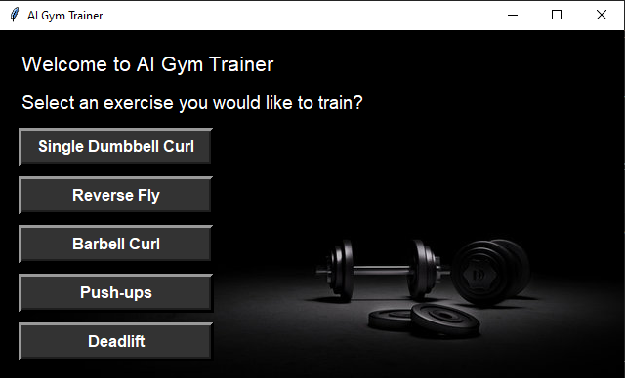

1. **Bicep Curl:**

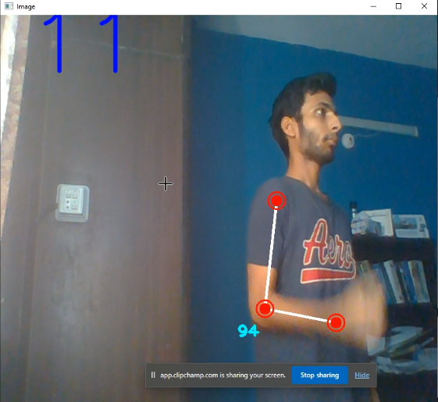

1. **Reverse Fly:**

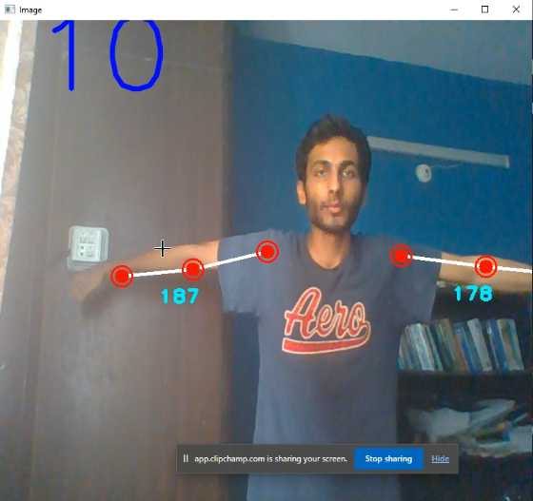

1. **Barbell Curl:**

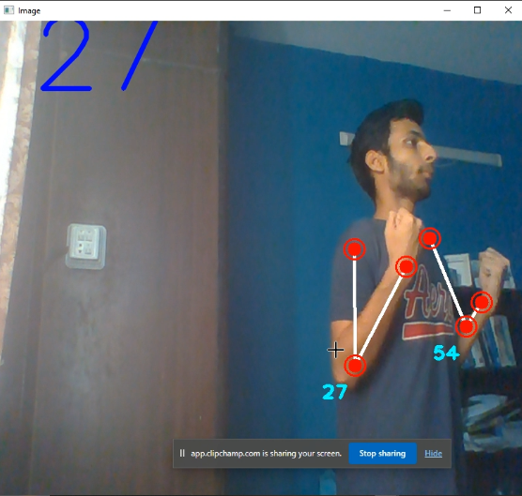

1. **Pushup:**

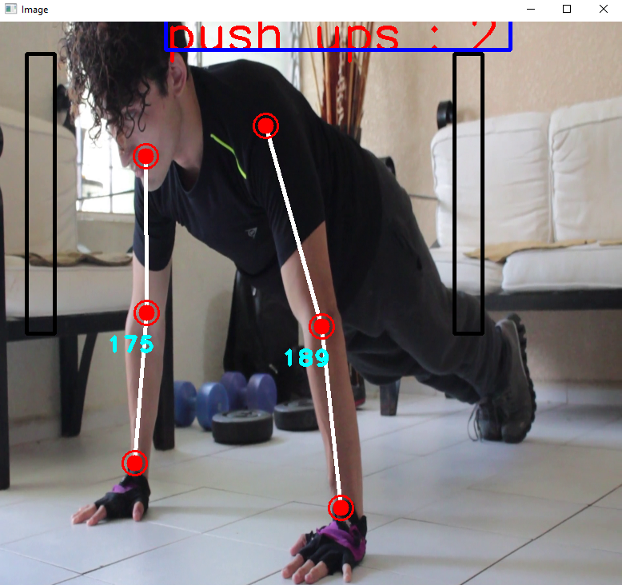

1. **Deadlift:**

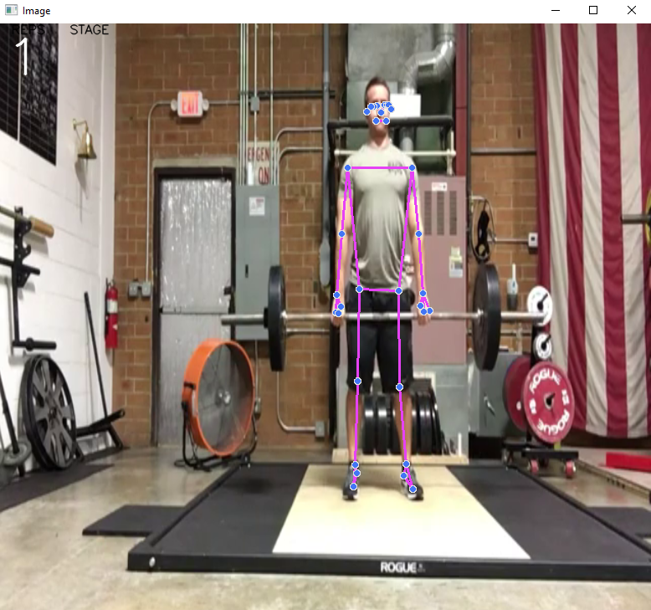

1. **Fit Sync App:**

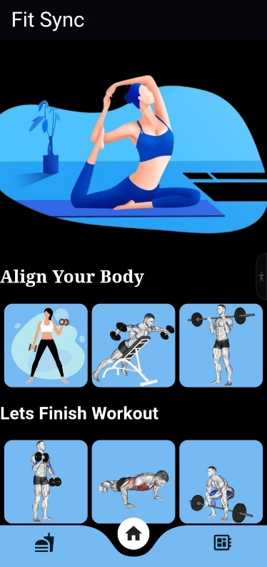

**Future Work:**

* **Reduced Latency:** Optimize code efficiency and data processing algorithms to minimize delays and ensure a smoother user experience.
* **Enhanced Synchronization**: Improve data synchronization protocols to ensure seamless transfer of workout data between the app and backend server.
* **Refined Machine Learning:** Continuously refine machine learning algorithms for more accurate calories as well as diet recommendations and personalized fitness insights.
* **User Feedback Mechanisms:** Implement feedback mechanisms to gather user insights and prioritize feature enhancements based on user needs.

**Conclusion:**

The Fit Sync Android app represents a significant step forward in the realm of fitness technology, offering users a convenient and intuitive solution for tracking their workouts, monitoring their progress, managing their diet and achieving their fitness goals. With its user-friendly interface, advanced features, and seamless integration with the AI Gym Trainer and diet recommendation system, Fit Sync empowers users to take control of their health and fitness journey with confidence.

As we continue to innovate and expand our platform, we remain committed to providing users with the tools and support they need to lead healthier, happier lives. Thank you for your interest in Fit Sync, and we look forward to helping you achieve your fitness aspirations.

**References:**

* OpenCV: [OpenCV: OpenCV Tutorials](https://docs.opencv.org/4.x/d9/df8/tutorial_root.html)
* Mediapipe: [MediaPipe Studio (google.com)](https://mediapipe-studio.webapps.google.com/home)
* AI Gym Trainer: [IRJET-V10I1131.pdf](https://www.irjet.net/archives/V10/i1/IRJET-V10I1131.pdf)
* Diet Recommendation System: [IRJET-V8I4702.pdf](https://www.irjet.net/archives/V8/i4/IRJET-V8I4702.pdf)